Ideation Phase
Empathize & Discover

Date | 07 August2026
Name | Shahid afridi M
Project Name | Shopez : E-commerces
Maximum Marks | 4 Marks

Empathy Map Canvas:
To build an effective map for your project, gather your team and map out these core perspectives:
Think & Feel: What occupies the user's mind? What are their hidden worries, hopes, and emotional reactions?
Hear: What do friends, family, influencers, and colleagues say that influences the user's choices?
See: What does the user encounter in their environment, on competitors' sites, or in daily life?
Say & Do: What does the user outwardly state, and how do they actually act when interacting with the problem?
Pains: What are the user's biggest frustrations, obstacles, and anxieties holding them back?
Gains: What are the user's ultimate goals, desired outcomes, and measures of success?

Example:
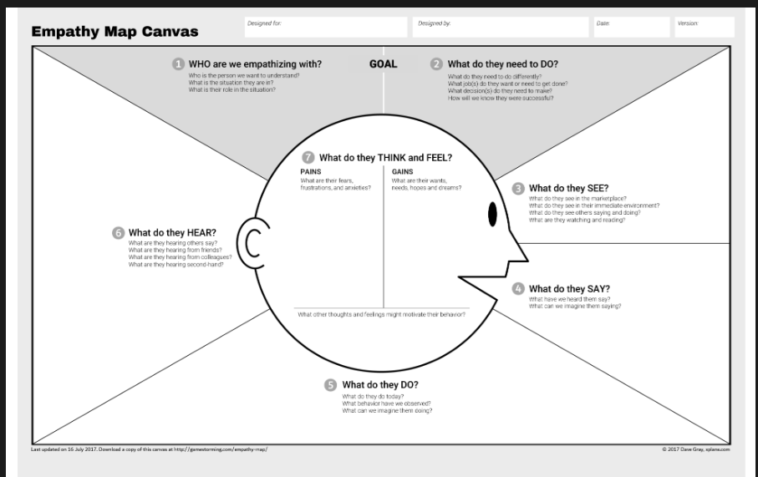

Example: Food Ordering & Delivery Application
